Guide to Create a CodeWarrior Assembly Project

This guide provides instructions for creating a new project that is compatible with the Wytec Dragon12+ evaluations boards. This board is compatible with CodeWarrior Development Studio for S12(X) v5.0 and v5.1. However, only CodeWarrior Development Studio Special Edition v5.2 is currently available, and it dropped support for the microprocessor variant used on the board. The steps below should work on special edition v5.0 installed in the Microcomputers Lab and on Special Edition v5.2 with the extra steps taken as descibed at the end of this guide. If you just have v5.2 installed and haven’t installed the additional files, you won’t see the correct options.

1. Open Freescale CodeWarrior, and click on “New Project…” under *File*, or on “Create New Project” if the pop-up window still shows on startup.

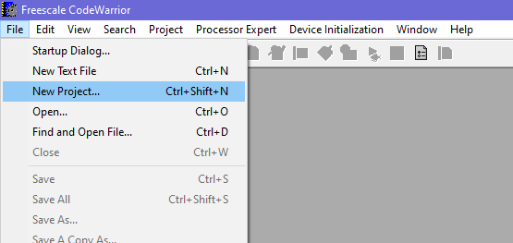 OR 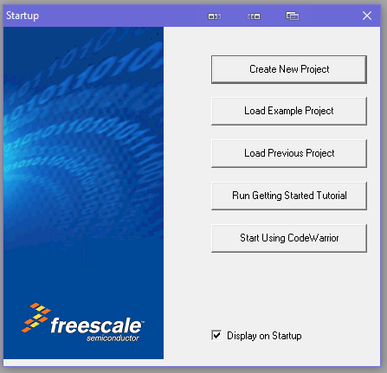

1. (Optional) CodeWarrior may display several types of projects under the Projects tab. If you see this, select “HC(S)12(X) Microcontrollers New Project Wizard” . If you don’t see it, don’t panic and keep going.
2. Depending on the version of CodeWarrior, you may be prompted for a name for the project and directory next (or it may show up later). Enter appropriate values, and keep in mind that A LOT of development software does not like and spaces in the path or filenames.
3. In the “HC(S)12(X) Microcontrollers New Project Wizard” window, select MC9S12DG256B under the HCS12D family. For the default connection, select “Full Chip Simulation”. Note that if you are in lab using Codewarrior v5.0 and have access to the physical development board, you would select “HCS12 Serial Monitor”. This option is not supported in v5.2.

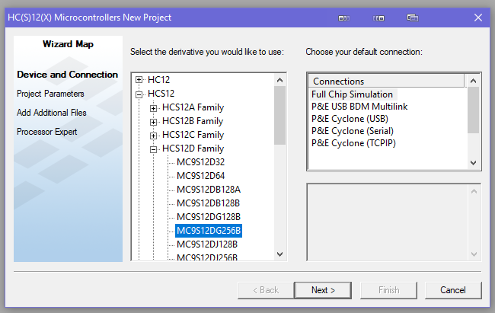

Figure 1 CodeWarrior v5.2 when working virtually

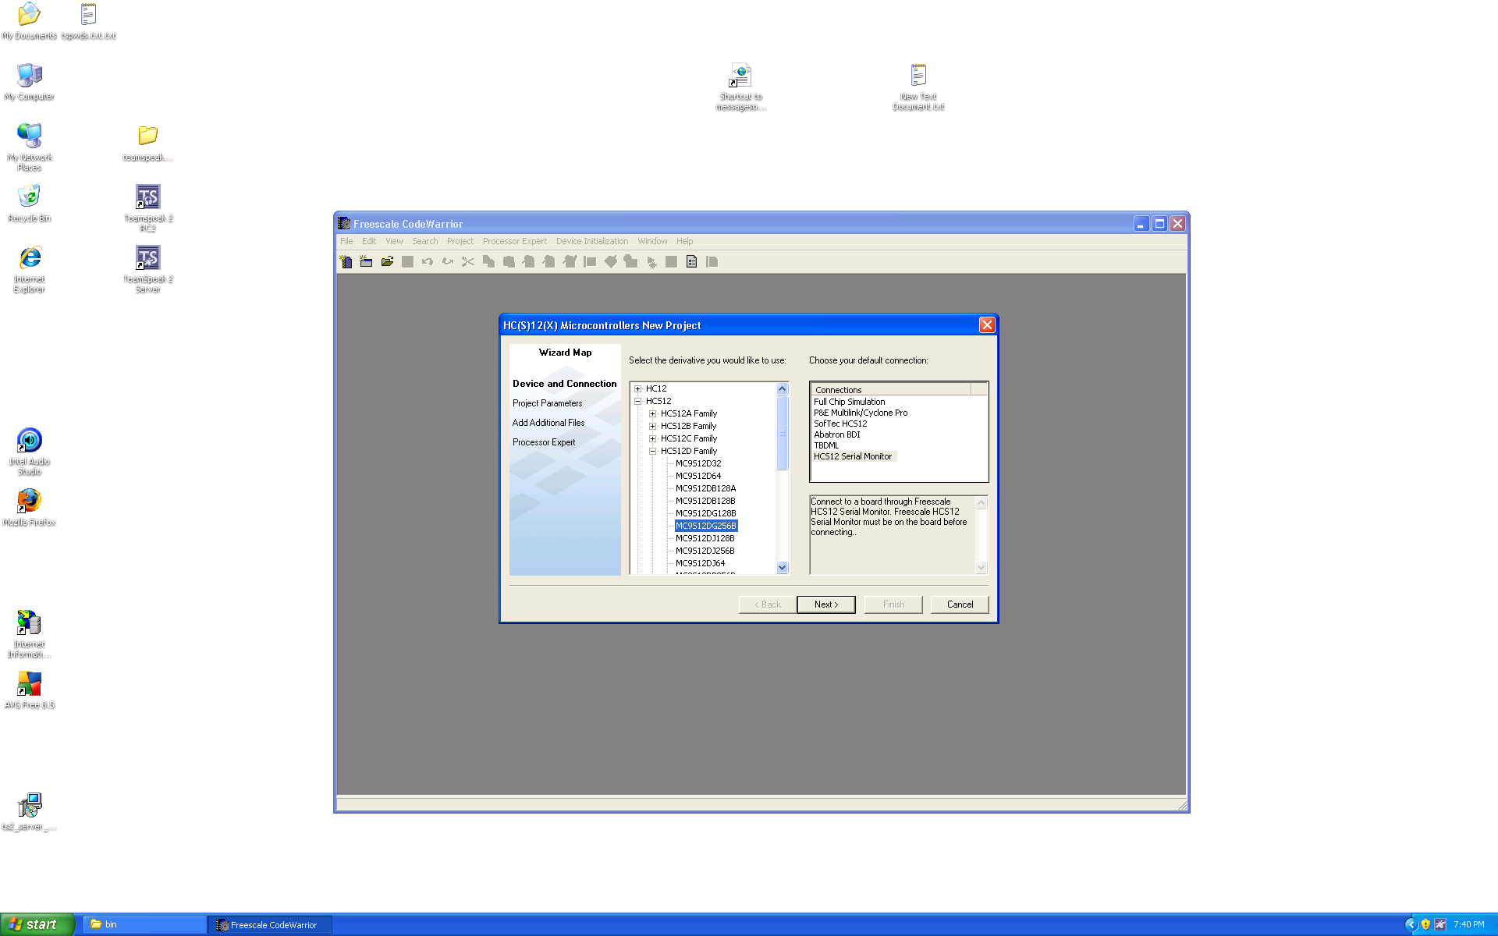

Figure 2 CodeWarrior v5.0 in lab working with hardware

1. In the Project Parameters window, only “Relocatable Assembly” should be checked. If the project name and location were entered earlier (usually with v5.0), they shouldn’t need to be changed. If they haven’t been entered yet, change them now. Then, select “Finish”.

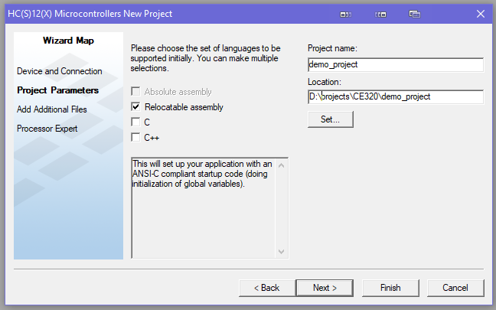

1. (Only for v5.0 in lab with hardware) Once CodeWarrior has initialized the project, open the HCS12_Serial_Monitor.prm file under Project Settings\Linker Files. Change the line

RAM = READ_WRITE 0x1000 TO 0x3FFF;

to

RAM = READ_WRITE 0x1000 TO 0x2FFF;

and save the file. If you are only going run the code through simulation, you do not need to do anything for this step.

1. Open *main.asm* in the file hierarchy. For some secret reason, the “blank” assembly project has code that calculates Fibonacci numbers. Delete all code in the main section *AFTER* the LDS #__SEG_END_STACK line and delete the declarations for *Counter* and *FiboRes* under MY_EXTENDED_RAM. You will probably need to add an ORG $XXXX line for your specific inputs and outputs, and you need an infinite loop at the very end of the program to prevent the microprocessor from trying to execute the undefined memory after your program. With the infinite loop added, you main.asm file should look something like the code below.

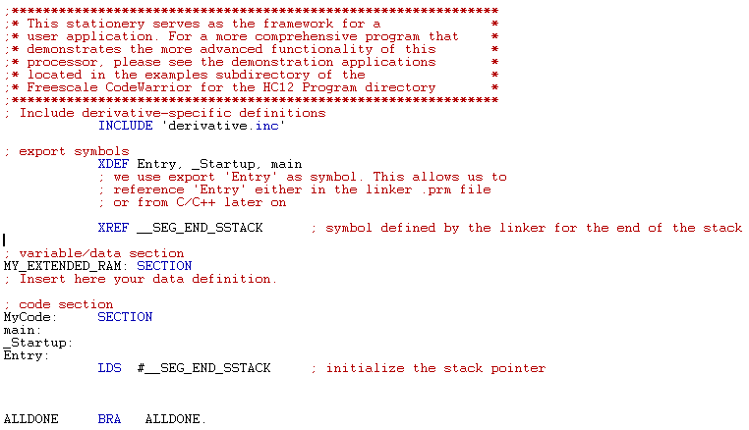

Your main program code would be typed between the LDS instruction and the BRA instruction.

Installing CodeWarrior 5.2 with Support for the MC9S12DG256D

1. Download CodeWarrior® Development Studio for HCS12(X) from the NXP web site. At the moment, the link to the download is [here](https://www.nxp.com/lgfiles/devsuites/HC12/CWS12v5.2_Win_b151201_se.exe). With a little obvious searching and clicking, the download page looks like this (for the moment).

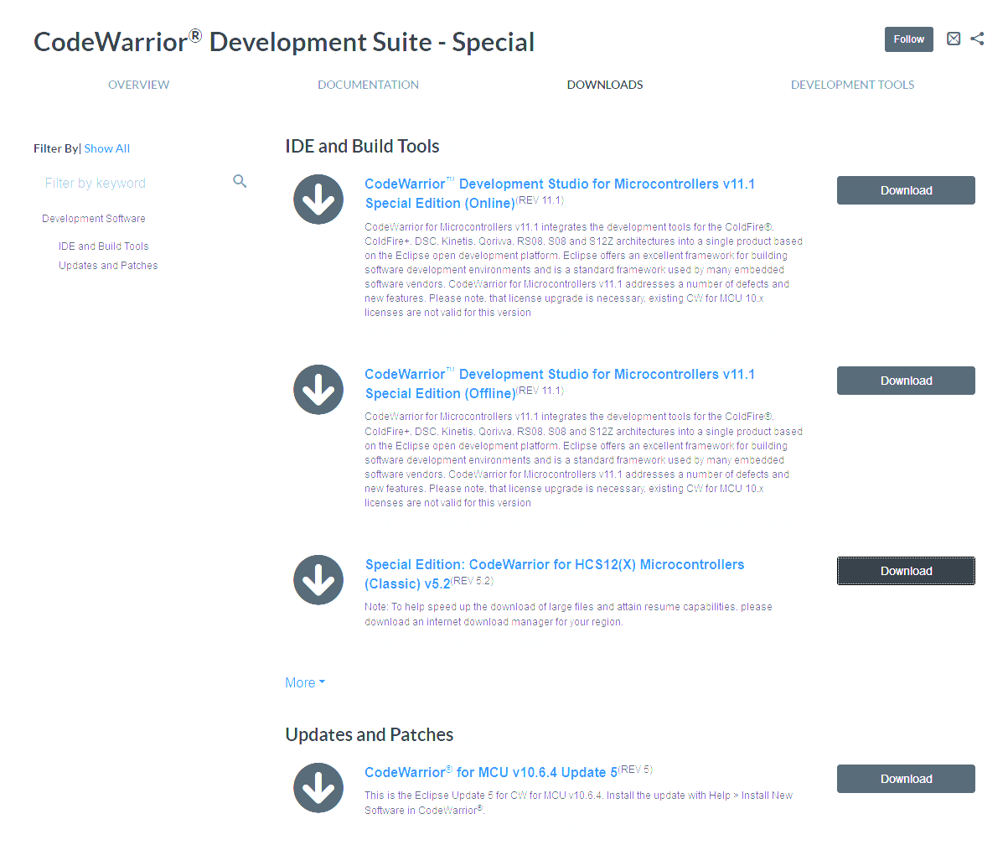

1. Install CodeWarrior by running the executable and following the prompts.
2. Download cw_5_2_missing_pieces_v3.zip from Blackboard. Unzip the file, and you should see three folders named Bin, Lib, and Prog.
3. Find the installation directory for CodeWarrior (it should be C:\Program Files (x86)\Freescale\CWS12v5.2 or something similar by default). You should see several folders that include the three mentioned above. Copy the ones from step 3 into this folder, and when prompted, overwrite preexisting files. You should now have all variants available in v5.2, although they are officially not supported by NXP anymore.